
Supplier’s
Declaration of Conformity

With The 47 CFR, Part 15 Subpart B Of FCC of CSA Requirement

Hereby certifies that

Type of device | : Tilt-rotor Drone
Model Name | : AF200
Additional Model name | : N/A
Manufactures and address :

NARMA INC.

169-84 Gwahak-ro, Yuseong-gu, Daejeon, 34133, Korea

We certify that above the products had performed test on our laboratory and it was confirmed to comply with FCC and CSA requirement. These products might be marketed at the US accordance to SDOC of FCC based on the standard 47 CFR, Part 15 Subpart B. The test was performed accordance to the procedures from ANSI C63.4:2017. Test data and results are issued from the EMC test report.

[Place, date] | [Name and signature of person responsible]
 | 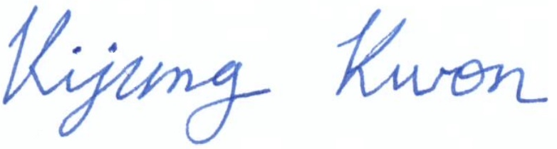
2022-11-01 | Kijung, Kwon / CEO

